**Task9- ChatGPT**

**Aligning Elements in CSS**

CSS provides various methods for aligning elements on a web page, utilizing different display properties such as block, inline, inline-block, and flex. Each of these properties affects how elements are displayed and how they can be aligned.

**Display Properties**

1. **Block**: Elements that take up the full width available, starting on a new line. Examples: <div>, <h1>.
2. **Inline**: Elements that only take up as much width as necessary and do not start on a new line. Examples: <span>, <a>.
3. **Inline-Block**: Similar to inline elements but can have width and height set, and can be vertically aligned. Example: <button>.
4. **Flex**: A flexible box model that allows for responsive layouts. Children of a flex container can be aligned in various ways.

**Example HTML Document**

Here's an example that demonstrates various alignment techniques:

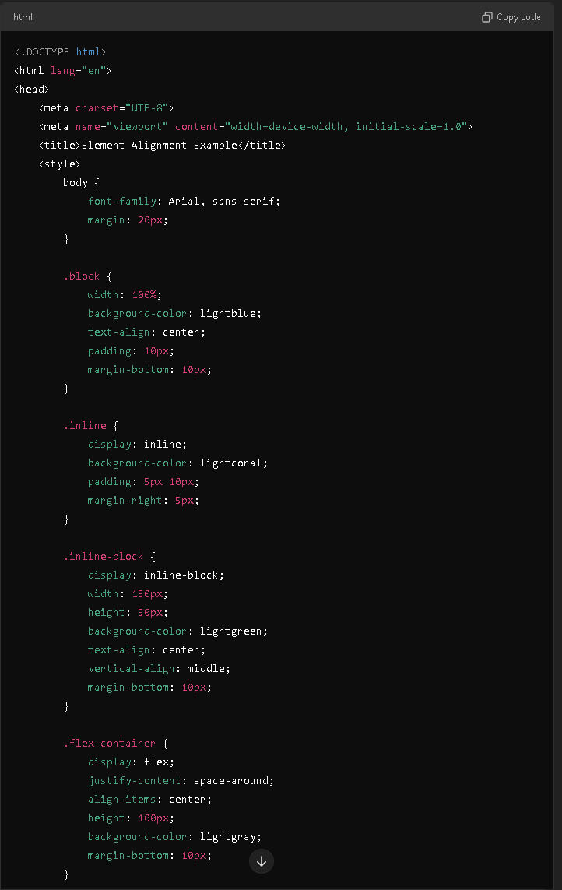

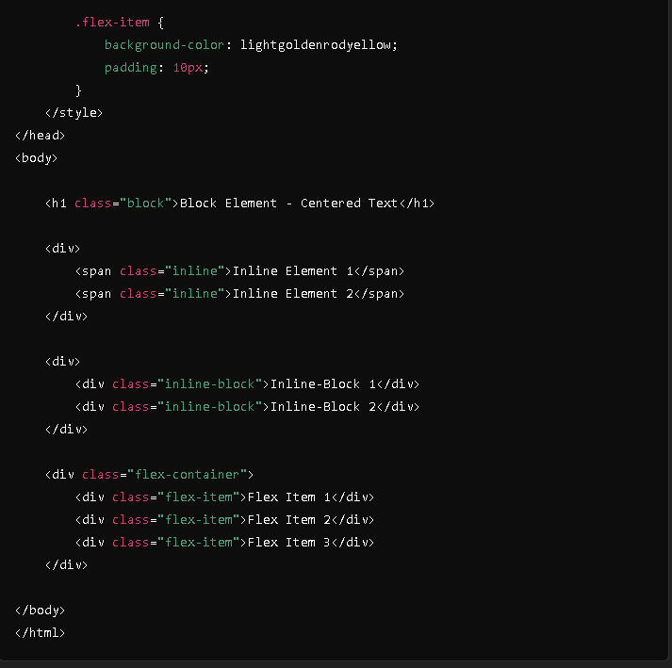

**Result:**

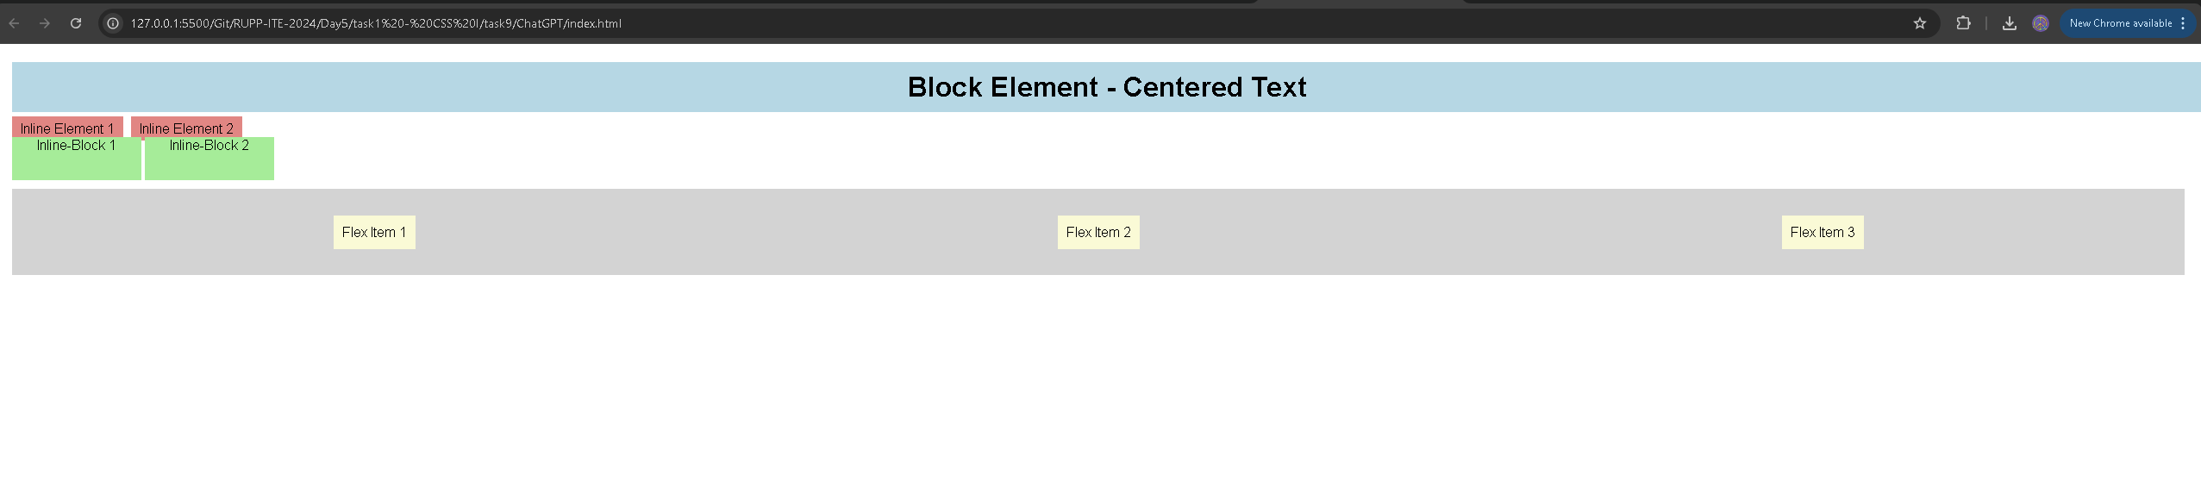

**Explanation of Each Method Used**

1. **Block Alignment**:
   * The <h1> with the class .block is a block-level element that takes the full width of its parent and centers its text with text-align: center;.
2. **Inline Alignment**:
   * The <span> elements with the class .inline are displayed inline. They sit next to each other and only take up as much width as necessary. Their background color and padding provide visibility.
3. **Inline-Block Alignment**:
   * The <div> elements with the class .inline-block demonstrate the inline-block property. They can be sized and vertically aligned. This allows them to sit inline while maintaining block-like characteristics.
4. **Flex Alignment**:
   * The .flex-container uses the display: flex; property to create a flexible layout. The justify-content: space-around; property evenly distributes the flex items within the container, while align-items: center; vertically centers them.

**Summary**

Using these methods, you can effectively control how elements are aligned on your web page. Understanding and using block, inline, inline-block, and flex properties helps create organized, visually appealing layouts that enhance user experience.